Dear Business Owner,

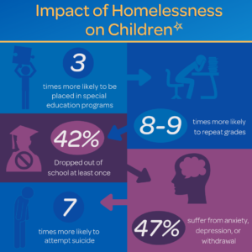
Did you know that children who experience homelessness are 8-9 times more likely to repeat a grade? 47% of children who experience homelessness suffer from depression or anxiety.
When a child or teen experiences homelessness, it is not an isolated incident. Once they regain stability, they do not simply go back to having a “normal life”. They often suffer negative impacts emotionally and educationally, among others.
We don’t think this is right. We believe every child deserves a home. We know you do too, which is why you have been so generous to Family Promise in the past!
At Family Promise, we work every day to ensure that happens. Because of partners like you, we have a 65% success rate of moving families from homelessness to home.
You can make a difference in the life of a family by sponsoring our Night without a Bed event. On October 8-9, we are challenging people in our community to sleep somewhere not in their bed (couch, tent, car, etc.) for the night to experience what families in our community experience each night. Please read the enclosed letter for details on how this event works.
- Our $500 sponsors will receive social media recognition and be included on our placemat programs for the dinner.
- Our $750 table sponsors will receive social media recognition, be included on our placements for dinner, their name and logo will be featured at the table, and they will have a banner at the event.
- There are additional exclusive sponsorship opportunities available. For more on those, please contact me at 717-737-1100 or director@familypromisehcr.org.
Thank you for your consideration and your generosity. The only way we can keep families together in their moment of crisis is through the support of generous community partners such as you.
Sincerely,

Matthew Wagner
Executive Director
Family Promise HCR

Family Promise of Harrisburg Capital Region
Night without a Bed
Sponsorship Form 2022
Name of business/sponsor:
Contact person: Title:
Email address: Phone:
Mailing address:

Sponsorship level:
$500 level sponsor (includes social media recognition and business name on placemat)
$750 level sponsor (includes the above as well as name and logo at dinner table and banner during meal)
Other (please specify amount):

Donation information:
I have enclosed a check with this form.
I have made a donation online at: http://familypromisehcr.org.harnessapp.com/wv2/campaign/7321
I would like someone to contact me about an exclusive sponsorship opportunity.
Other (please specify):
Thank you for your generosity and ensuring every child has a home!

